Experimental stations planned for the installation on PIK reactor

Experiments on the neutron beams are performed mainly with slow neutrons. The placement of tangential channels and the employment of neutron guides provide low background conditions of the fast neutrons and gamma rays for researching. The use of the advanced neutron guide system can provide simultaneous work of up to 50 experimental installations.

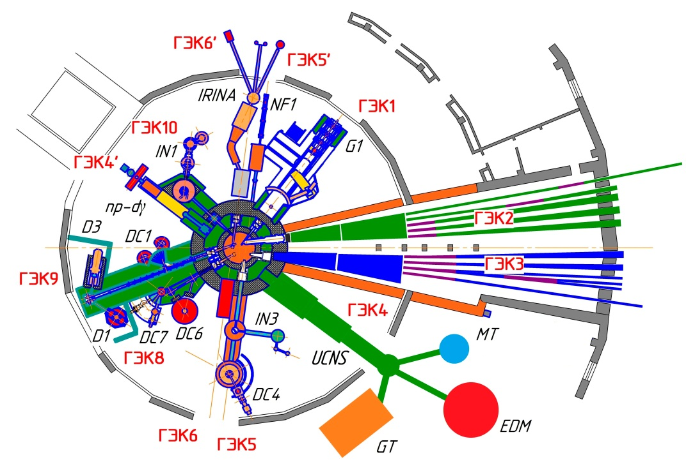

The planned location of the experimental stations
in the horizontal channels hall

UCNS – The source of ultracold neutrons with superfluid helium.  GT – The measurement of the neutron lifetime in a gravitational trap "Gravitrap".  MT – Measurement of the neutron lifetime in the magnetic trap.  EDM – EDM of the neutron, magnetic resonance spectrometer at UCN.  np-dγ – Asymmetry and the circular polarization of γ-rays.  G1 – crystal diffraction polarizer-monochromator.  NF1 – polarized beam for nuclear fission physics.  IRINA – Instrument "IRINA" for  study radioactive isotopes. | D1 – Superposition multisection powder diffractometer.  D3 – Thermal neutrons powder multidetector diffractometer for research at high pressures.  DC1 – Four-circle diffractometer.  DC4 – Polarized neutron diffractometer with a two-dimensional detector POLDI (HZG).  DC6 – Texture diffractometer TEX (HZG).  DC7 – Stress diffractometer ARES for residual stress measurement (HZG).  IN1 – Three-axis thermal neutron spectrometer.  IN3 – Three-axis polarized neutron spectrometer SPIN.

Neutron guide hall

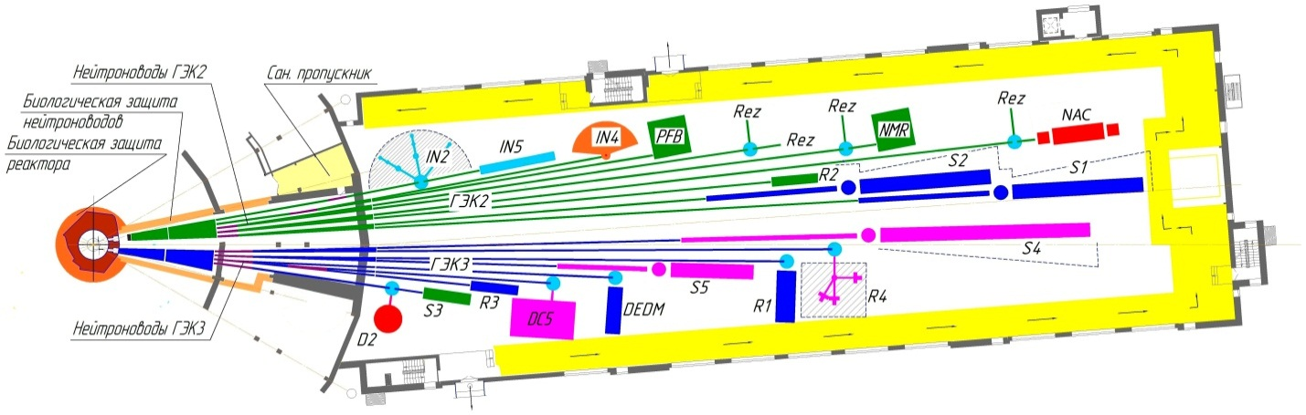

The planned location of the experimental stations
in the neutron guide hall

R1 – Polarized neutron reflectometer with the vertical plane of reflection REVERANS.  R2 – Neutron optical reflectometer NORMA.  R3 – Reflectometer with vector polarization analysis UNISON.  R4 – Polarized neutron reflectometer with polarization analysis NERO (HZG).  DC5 – Ultra-small-angle diffractometer on a perfect crystal DCD (HZG).  D2 – Multicounter cold neutron powder diffractometer.  DEDM – Instrument for measuring the electric dipole moment by the neutron crystal diffraction method.  NAC – β-decay of the neutron, angular correlations.  NMR – Beta-NMR Spectrometer. | PFB – Beam for the physics of elementary particles.  IN2 – Three-axis cold neutron spectrometer.  IN4 – Multi-rotor TOF spectrometer.  IN5 – Modified spin echo spectrometer SEM.  S1 – Small-angle polarized neutron diffractometer TENZOR.  S2 – Small-angle diffractometer MEMBRANA.  S3 – Spin-echo ultra-small-angle scattering instrument SESANS.  S4 – Small-angle polarized neutron diffractometer SANS-2 (HZG).  S5 – Small-angle polarized neutron diffractometer SANS-3 (HZG).

Inclined channels hall
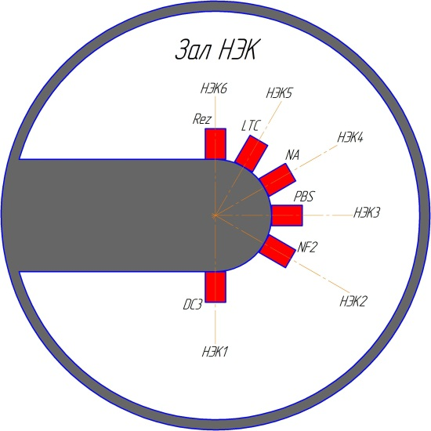

The planned location of the experimental stations
in the inclined channels hall

DC3 – Single-crystal diffractometer for the study of macromolecular compounds.
NF2 – Research multiplicity of fission fragments.
PBS – Prism beta-spectrometer.
NA – Instrumental neutron activation analysis.
LTC – Low temperature channel (STC).

